- The Bank of England’s Monetary Policy Committee held Bank Rate at 3.75% this week. We still expect the MPC to keep Bank Rate unchanged this year, but it wouldn’t take much to tip the balance towards rate hikes. Continued strength in energy prices or evidence that the MPC has underestimated the indirect impacts of higher energy prices could convince the majority to tighten policy.
- New population projections from the Office for National Statistics assume much lower levels of net inward migration, leaving the population 6.5mn smaller in 2060 than under its previous projections. We had already adopted a lower near-term profile for net inflows, but will now incorporate the ONS’ lower medium-term assumptions. This will knock 0.1ppt-0.2ppt a year off our long-term forecast for UK GDP growth.
On the face of it, an 8-1 vote to keep Bank Rate at 3.75% at this week’s meeting suggested the Monetary Policy Committee is in no hurry to take a strong view on the implications of the Middle East conflict for monetary policy. But while we will maintain our baseline (modal) forecast that policy will remain unchanged into next year, we think the risks of summer tightening have increased.
The MPC used three scenarios with varying profiles for energy prices and second-round effects to frame its thinking. Scenarios A (recent market pricing for energy and no second-round effects on pay and pricing power) and B (higher energy prices and limited second round effects) were more benign inflation outcomes than our baseline forecast (Chart 1). Scenario C (higher energy prices for longer with strong and more persistent second round effects) yielded a near-term inflation profile between our baseline and our prolonged war scenario.
Chart 1: The MPC presented three scenarios for inflation, with most members favouring Scenario B
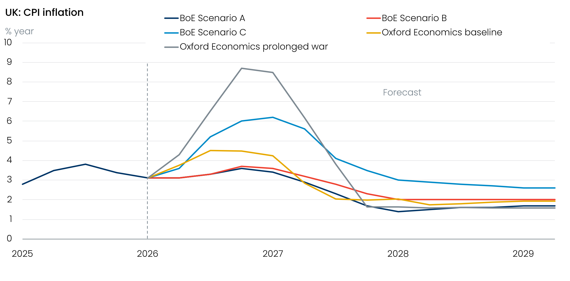
Sources: Oxford Economics, Haver Analytics

The majority of MPC members put the most weight on Scenario B. But Catherine Mann and Megan Greene offered a more hawkish take that strongly suggested they will vote to hike in June. The intentions of other members are opaque. Modelling shown in the Monetary Policy Report suggested that all three scenarios imply some rate hikes in the near term, yet most of the individual paragraphs betrayed little urgency to tighten. And while most stressed the importance of second round effects through pay and firms’ pricing power, they didn’t volunteer any precise criteria against which we could judge their likely reaction function.
Our May baseline forecast (due to be published on May 11) will assume that disruption in the Strait of Hormuz will be slower to clear, keeping oil and gas prices higher in early summer. But we still expect energy prices to drop back sharply in H2. This easing in energy prices and forward-looking survey evidence suggesting that second-round effects will remain modest should keep the MPC in a watching brief.
But it’s a close call and we identify two factors that could lead the MPC to tighten policy in the summer. First, there’s little sign of a resolution to the conflict, and continued strength in energy prices could tip the balance. Second, we think there’s a good chance that inflation will surprise the MPC on the upside because they may have underestimated the strength of indirect pressures from higher energy costs on the prices of other goods and services (Chart 1).
The May forecast will also incorporate the official population projections published this week. The Office for National Statistics made large cuts to the assumption for net inward migration in its principal projection, taking on board recent much lower data. The changes leave the ONS’ projection for the total population in 2060 nearly 6.5mn lower than its previous projections, which were published in January 2025.
We had already made similar changes to our assumptions for this decade earlier this year, so the revisions to our near-term forecasts will be relatively small. But we will adopt the new ONS assumption of net inflows of 230,000 a year for the medium-term. This will leave our projection for the population in 2060 around 3.1mn lower than our previous forecast (Chart 2). The impact on projections of the working-age population is even more stark. Our new assumptions will see little growth from the mid-2030s, apart from a period from 2044-2046 when the state pension age will rise. We now expect the working age population will consistently contract from the mid-2040s. As a result of these changes, we will cut our long-term GDP growth forecasts by 0.1ppt-0.2ppt a year.
Chart 2: The ONS has slashed its long-term population projections; our changes will be smaller but still material
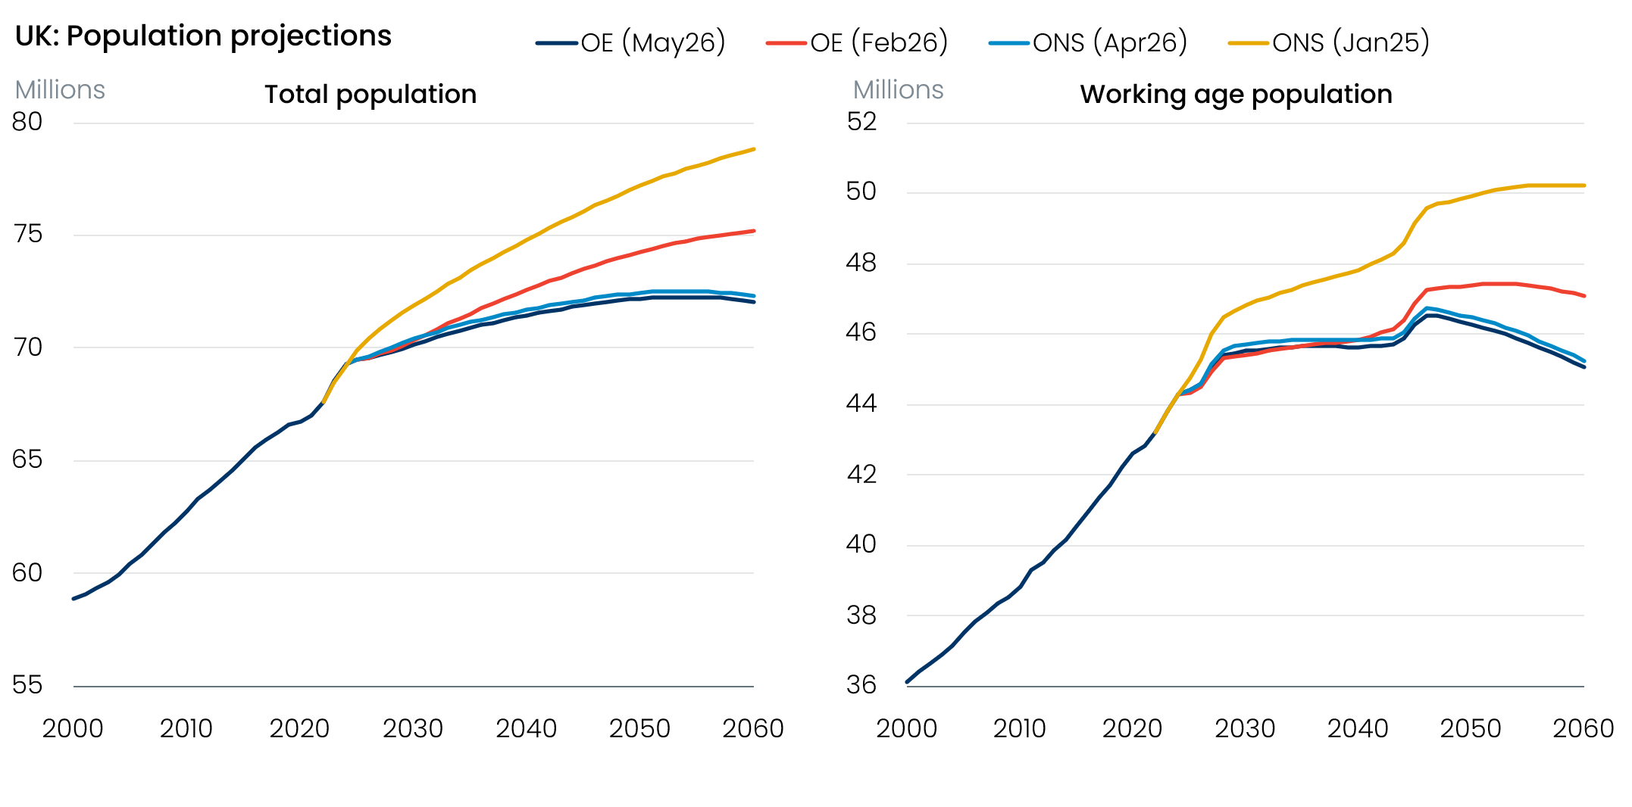
Sources: Oxford Economics, ONS

The week ahead
Next week’s only releases are the remaining S&P Global surveys for April. The flash survey reported surprise increases in the services and composite PMIs, after March’s slump. The flash survey closed on April 21, and we think the subsequent news flow around the Middle East will have caused sentiment to deteriorate. So we look for the final outturns for the services and composite PMIs to come in slightly lower than the flash results.
Table 1: Week ahead calendar
Date | Events | Period | Measure | Unit | Previous | Forecast
May 6 | S&P Global services | Apr | PMI | % bal | 52.0 | 51.5
May 6 | S&P Global composite | Apr | PMI | % bal | 52.0 | 51.5
May 7 | S&P Global construction | Apr | PMI | % bal | 45.6 | 47.0
Source: Oxford Economics

Key forecasts
Table 2: UK forecast overview
(ANNUAL PERCENTAGE CHANGES UNLESS SPECIFIED)
 | 2023 | 2024 | 2025 | 2026 | 2027 | 2028
GDP | 0.3 | 1.1 | 1.4 | 0.6 | 0.8 | 1.7
Private consumption | -0.3 | -0.1 | 0.8 | 0.4 | 0.4 | 1.4
Fixed investment | 0.5 | 1.8 | 4.3 | 0.2 | 1.4 | 2.6
Government consumption | 2.1 | 2.9 | 1.7 | 1.9 | 1.6 | 1.4
Consumer prices | 7.3 | 2.5 | 3.4 | 3.9 | 2.7 | 1.9
Unemployment rate (%) | 4.1 | 4.3 | 4.9 | 5.3 | 5.4 | 4.9
Current a/c balance (% of GDP) | -3.6 | -3.0 | -2.4 | -3.2 | -3.1 | -2.6
Government balance (% of GDP) | 5.2 | 5.2 | 5.1 | 4.2 | 3.6 | 2.9
Central bank policy rate (%, EOP) | 5.25 | 4.75 | 3.75 | 3.75 | 3.50 | 3.00
10yr govt. bond yield (%, EOP) | 3.54 | 4.57 | 4.47 | 4.73 | 4.20 | 3.83
Exchange rate (US$ per £, EOP) | 1.27 | 1.25 | 1.35 | 1.29 | 1.30 | 1.30
Exchange rate (euro per £, EOP) | 1.15 | 1.21 | 1.15 | 1.11 | 1.10 | 1.10
Source: Oxford Economics
Table 3: Quarterly forecasts for the UK
 | 2025 |  |  |  | 2026
 | Q1 | Q2 | Q3 | Q4 | Q1 | Q2 | Q3 | Q4
GDP (% year) | 1.8 | 1.4 | 1.3 | 1.0 | 0.9 | 0.7 | 0.5 | 0.5
CPI inflation (% year) | 2.8 | 3.5 | 3.8 | 3.4 | 3.1 | 3.7 | 4.4 | 4.4
Bank Rate (%, EOP) | 4.50 | 4.25 | 4.00 | 3.75 | 3.75 | 3.75 | 3.75 | 3.75
10yr gilt yield (%, EOP) | 4.70 | 4.48 | 4.70 | 4.47 | 4.88 | 4.80 | 4.79 | 4.73
US$ per £ (EOP) | 1.29 | 1.37 | 1.35 | 1.35 | 1.32 | 1.31 | 1.30 | 1.29
Euro per £ (EOP) | 1.20 | 1.17 | 1.15 | 1.15 | 1.14 | 1.14 | 1.12 | 1.11
Source: Oxford Economics

Latest Country Economic Forecast:
April 20, 2026

Recent publications

Data Insights
Mortgage activity strengthened in March, despite higher interest rates
Manufacturing PMI rise masks weakness
March retail bounce too good to be true
Activity growth is likely to slow sharply, despite rebound in April’s flash PMIs
Public finances on track

Research Briefings
MPC maintains a watching brief, but chances of higher rates are rising
Residual seasonality issues continue to flatter activity growth in Q1
MPC preview – Maintaining the ‘wait and see’ message
What different migration profiles mean for the economy and public finances
Why higher rates may be on the MPC's agenda

Contacts

Oxford Economics' UK team
- Andrew Goodwin – Chief UK Economist – agoodwin@oxfordeconomics.com
- Edward Allenby - Senior UK Economist - eallenby@oxfordeconomics.com

